Data Note: Space Cadet
Orbital-debris reentry data. Prepared with train and valid rows only; the test split was reserved before exploration.

1. Data source and scope
The project asks how long a piece of tracked space junk has left before it burns up in the atmosphere, and whether solar activity helps predict it. Four public sources are combined:
- Satellite catalogue (Space-Track), 71,139 objects, 24 columns: type, owner, launch date, orbit, radar size.
- Reentry (decay) messages (Space-Track), 143,406 rows, 13 columns: when each object came down. These give the labels.
- Orbital-element history (Space-Track), 500,000 rows, 40 columns, covering only 97 objects (a partial pull).
- Space weather (CelesTrak), 25,450 daily rows, 31 columns: solar flux (F10.7) and geomagnetic indices, 1957 onward.
These are joined into a modelling table, the panel: 705,440 rows and 81 columns. One row is one object on one observation date, with the Sun’s recent activity and the days until that object reentered. Objects still in orbit have no label and are called censored. The panel keeps low orbits only (perigee at or below 1,000 km) and covers observations from 1957 to 2026.
The dashboard does not read the full panel. It reads a training sample stored in Supabase: 10,028 rows, 81 columns and 921 objects, all objects with an observed reentry. Charts therefore describe that sample, not the whole catalogue.

2. Test-set reservation
The panel is split by date so the test set is the most recent period: train 493,828 rows (1957 to Dec 2023), valid 105,882 rows (Dec 2023 to 27 Dec 2025) and test 105,730 rows (28 Dec 2025 onward). The final test set used by the classification notebook is the part of that test split with an observed reentry: 3,084 observations from 1,029 objects. Their identifying keys (object id and date, no features or labels) are stored in dashboard/reserved_test.json. The dashboard asks Supabase for train and valid rows only and rejects any row that matches a reserved key, so the test data is never loaded or charted. The reservation is by row, so earlier training rows of the same objects remain in use. Nothing was explored or tuned on test.

3. Audit and cleaning
Counts are from checks on the full local panel (train + valid, 599,710 rows). The last column is what the current dashboard does; it deliberately preserves the original values.
Issue | Count | Action
Reentry outcome empty (censored) | 37.0% of rows | None in the dashboard sample, which keeps only reentered objects. Original outcomes are not recalculated.
Radar size, type, regime or country empty | 12,599 objects lack radar size | Filled with UNKNOWN for display only; stored rows unchanged.
Deep-space orbits (apogee > 100,000 km) | 381 rows, 108 objects | Flagged and hidden by default.
Reentry dates from prediction messages | 901 objects | Kept as supplied; not adjusted.
Constant columns | 1 panel column | Kept; not dropped.
Test rows in the upload | 105,730 in test split | Excluded; reserved keys also checked row by row.
Duplicate rows, negative ages | 0 found | Loader stops if keys repeat or the row count changes mid-read.

4. Key plots
Figures 1–3 are drawn from the full local train + valid panel (the sample is not on this machine), so the dashboard’s own charts will differ. The dashboard sample contains only reentered objects, so there it cannot show censoring or estimate reentry risk.
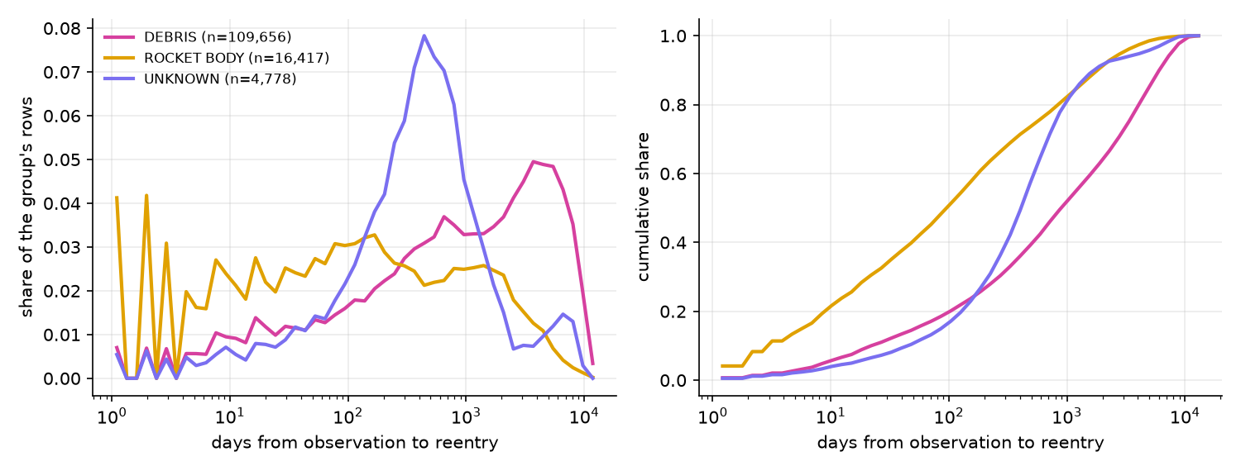
Figure 1. Days from observation to reentry, by object type (distribution and cumulative).
Rocket bodies fall fastest (median 96 days, 70% within a year); debris is slowest (median 894 days, 35% within a year). The curves only include objects that already fell, so they lean towards quick reentries. Objects still in orbit are handled as censored and counted as misses elsewhere.
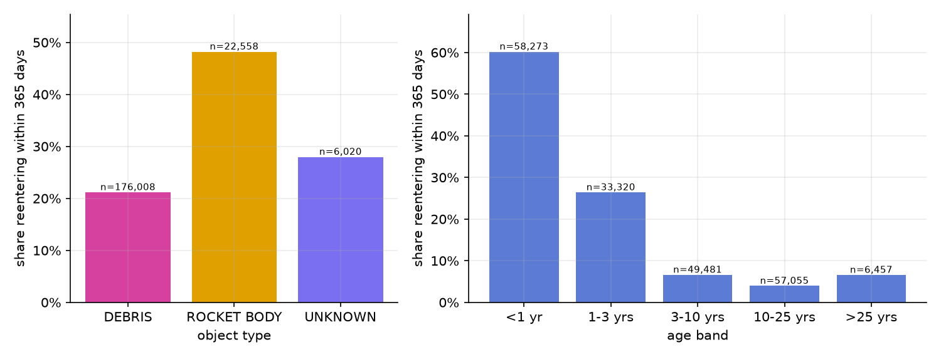
Figure 2. Share of observations reentering within 365 days, by object type and object age.
Rocket bodies reenter within a year most often (48%) against 28% for unknown objects and 21% for debris, and 60% of objects under one year old fall within a year versus 4–7% beyond three years. The age effect is partly built in by how rows were sampled (section 5), so we treat it as an upper bound.
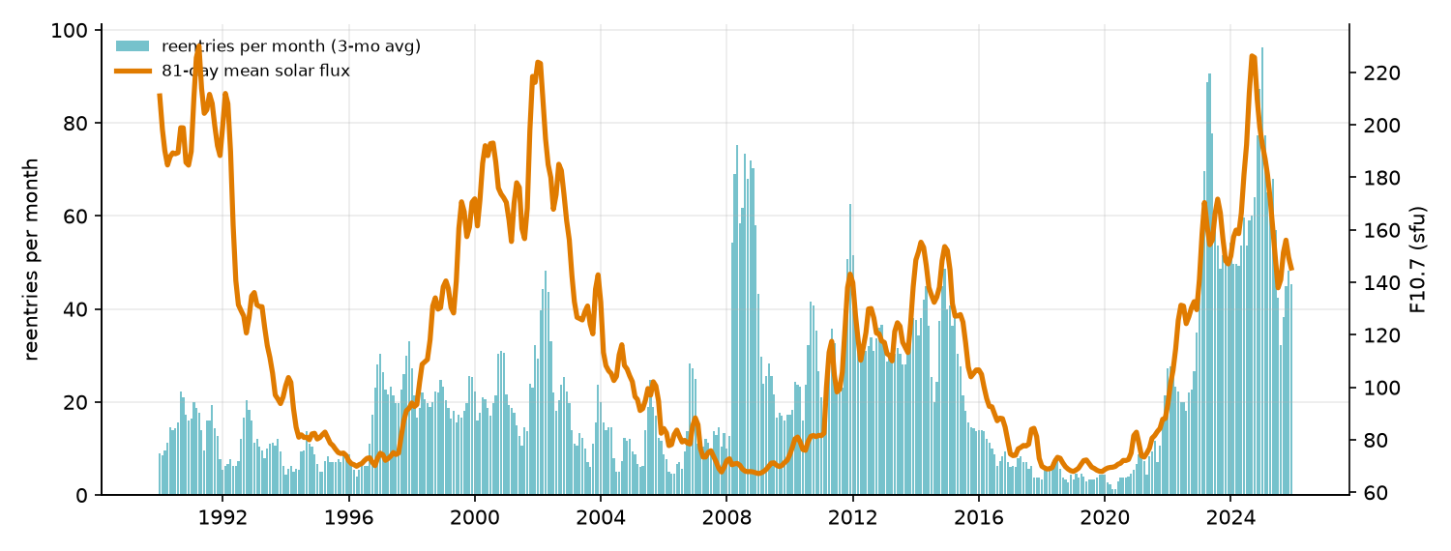
Figure 3. Reentries per month (bars) and 81-day mean solar flux (line), 1990–2025.
Reentry counts rise and fall with solar activity (rank correlation 0.44 over 432 months), peaking in 2023–2025 near the solar maximum. The match is partial: 2008 is a spike during a solar minimum, and catalogue growth also raises counts. The link is descriptive, not proof of cause.

5. Data-quality and sampling concerns

Quality
- Leakage. The catalogue orbit columns (perigee, apogee, regime and others) are last-on-file values, and for fallen objects they are the final orbit, so they partly encode the answer. They are flagged and not used for any plot above.
- Missing honest orbit features. The local orbit-history pull covers only 97 objects, so the as-of orbit columns that would replace the leaky ones are 99.9% empty in the panel. This needs the full pull.
- Missing or coarse fields. 18.7% of objects have no radar size class (the only stand-in for physical size); 901 reentry dates are predictions; 2,106 objects lack orbit elements. Each is flagged, not guessed.
- Back-dated breakups. Fragments carry their parent’s launch date, so breakups look like jumps at the parent’s launch.

Sampling
- Dashboard sample. Whole training objects were sampled in bands of reentry rate (seed 20261019, target 10,000 rows; 10,028 rows from 921 objects), and only reentered objects were eligible. It cannot estimate reentry probability for the full population.
- How rows were chosen. Twelve observation dates per object are spread evenly from launch to reentry, so each row is tied to its own outcome. Age and days remaining move together by construction. The project plan calls for fixed calendar snapshots, which the build code does not do yet.
- Who is represented. Only tracked objects, and only low orbits (7,324 catalogued objects have higher perigees). Debris is 60% of panel rows against 53% of the catalogue; three owners (CIS, US, PRC) make up 91% of rows.
- Uneven time and censoring. Rows per year grow from 6,562 in 1990 to 62,434 in 2025 (10% of all rows). 28% of train rows are censored against 79% of valid rows, because recent objects have not had time to fall.
- Selection. Labelled rows favour short-lived objects, which biases timing plots towards quick reentries. 16,047 of 57,101 objects (28%) appear in both train and valid, so rows are not independent.
- Generalisation. Findings apply to tracked, low-orbit debris and rocket bodies over 1990–2025 solar conditions, not to higher orbits or untracked debris.

6. Links
- Repository: https://github.com/kpaters4/space-cadet (branch D2); setup in dashboard/README.md
- Dashboard: Streamlit app reading Supabase, deployed to Modal with: modal deploy modal_app.py. Hosted URL: [add after deployment].
- Data dictionary: the dashboard’s Data dictionary tab (CSV download, all 81 columns with Supabase and pandas types) and src/SCHEMA.md

